**Chapter 3**

**Molecular Weights and Distributions**

References: Hiemenz-Lodge Chapter 1 or almost any polymer textbook

Introduction: It is time to return to the polydispersity issue. In doing so, we will be able to explore the limits of synthetic polymerization (step growth vs. living addition) which is also related to open aggregation vs. step-by-step self assembly.

Terminology

#

M

Monodisperse

#

M

Paucidisperse

#

M

Polydisperse

#

M

Bidisperse

Outline for MWD

1. Introduce Terminology and Various Averages
2. Biological Polymers and Colloids, where Aggregation May Resemble Polymerization
3. We will show how a physical view of polymerization/aggregation shows the two limits of “most probable” and “living” polymerizations.
4. The details are really controlled by Chemistry, especially by kinetics, but that’s another chapter!

1) Introduce Terminology & Various Averages

Various average MW's

We cannot always get the whole distribution. Even if we can, this is sometimes more information than we need. Whether by need or by desire, there are several ways to get "a number" which represents "the average." In fact, there are different kinds of average. Some experimental methods naturally correspond to one kind of average, while other experimental methods may be related to another kind of average. It is not always practical to do each kind of experiment, just as it isn’t always easy to do an experiment that resolves the entire distribution. Other quantities besides molecular weight also have to be averaged over the size distribution; for example, “size” has to be averaged (size is a tricky subject, though).

_________________________________________________________________________

Terms *M*o = monomer molecular wt.

e.g.  has *M*o = 104

*i* = how many repeats in the polymer

e.g. octamer: *i* = 8

*Mi = iM*o = mass of i-mer

*ni* = how many moles of chains in your sample have mass, *Mi*

*Ni* = *n*i⋅*N*A where *N*A = Avogadro’s number (sometimes, we might mix up *n*i and *N*i, an example of the REAL First Law of Chemistry: all errors in Chemistry are huge).

Number Average, *M*n

This is the simple average. Take all the chains in some sample. Weigh them, and divide by the total number of chains. This is the kind of average you get when you compute the average mass of students in the class.

*M*n = 

Where *xi* is the mole fraction of *i-mers*. The mole fraction is really the probability that a molecule selected at random will have *i* subunits. *M*n is the expectation value of *M*.

Degree of Polymerization

Often, a problem may be formulated in terms of how many repeat units there are, and not how massive the whole polymer is. We can define n = # average degree of polymerization

n =

Other symbols for n are  or . Just deal with it—polymer scientists will never agree on a single terminology for anything.

A useful relationship for *M*n when we may not know *M*i yet—e.g., we may not actually know the monomer at all (could be a competitor’s product). This relation is useful in Gel Permeation Chromatography, GPC, which we’ll cover soon enough.

let *gi* = mass of *i*-mers in the sample

*gi* = *niMi*

so... *ni* = 

and *Mn* = 

where *G* is the total mass of the sample. If you take the last form of this equation, and divide both top & bottom by the volume, *V*, of the solution, then define *ci = gi /V* to be the mass/volume concentration of species *i*, then we can write:

*M*n =

This relation is heavily used in GPC, which relies on concentration detectors. Note that the relation holds for any signal *proportional* to concentration, so you don't have to actually get the exact concentration.

Weight Average Molecular Weight, *M*w

Suppose we were computing average ages, not masses. We would add everyone's age in this room and divide by the number of people. But suppose we wanted to give added heft (or weight) to reflect the dignity and grace that can only come with experience. [1] Then we should assign to my age more importance. That is the general idea behind *M*w. In some measurements and practical applications, the heavy chains "count" more. Another example would be football; if you wanted to know the success of a team, you would count those hefty linemen more than the featherweight receivers. We define the weight average mass as:

*M*w = 

where *wi*is the weight fraction of *i*-mers. This scheme "weights" the average towards the mass of the polymers. Large polymers count more than small. But *gi* = *niMi* so….

*M*w = 

Z average Mass

We can continue the same trend--i.e., averaging over higher powers in both numerator and denominator:

*M*z = 

Z + 1 Average

*M*z+1 = 

Relationships

*M*n *=* 

*M*w *=* 

*M*z *=* 

*Similarly, M*z+1*=* 

_______________________________________________________________________

Exercise: get equivalent expressions for n and w and z. .

Most molecular weight methods measure *M*n or *M*w. A few measurements are related to *M*z. Some measurements relate to no simple average. An example is the viscosity average molecular weight, which we will treat later.

Ratios of Molar Mass Averages: the Polydispersity Index

Polymer chemists rely on the quotients of molecular mass averages. The most frequently used is *Mw/Mn*. Usually, this is called the Polydispersity Index or PDI. Look back through the equations above and convince yourself that, if only polymers of a single size are present in the distribution, the PDI will be 1.0. A PDI of 1.0 means monodisperse. Higher than 1.0 means varying degrees of polydispersity. Lower than 1.0 is mathematically impossible. For typical synthetic polymers we see PDI = 1.01 to 2.0 for research-grade materials and PDI of 10 or even higher for some commercial products.

_____________________________________________________________________

2) Biological Polymers And Colloids, Where Aggregation May Resemble Polymerization

This section may seem a bit out of place, but the point is that other disciplines besides polymer science care about distributions. Most proteins are monodisperse and some colloids, such as polymer latex paraticles, are very nearly monodisperse. Aggregation can have the effect of making the *as dissolved*protein orr colloid appear polydisperse. To the physicist or biological scientist, there may be little difference between such aggregation and polymerization. Let’s adopt that “achemical” viewpoint and see if we learn something.

Closed Aggregation (in this case, to produce only a trimer)

+

+

P

P

P

P

P

P

Your experiment may see single proteins (unimers) and trimers.

Open Aggregation (all possible species might form and remain reactive towards all other species).

P

+

P

P

P

P

P

P

P

P

+

P

P

P

P

P

P

P

P

+

P

P

P

P

P

P

P

P

P

Types of biopolymers

Some proteins really are polydisperse even when not aggregating. This can arise from attached sugar chains of varying length or adsorbed species (e.g., drugs) of some type in varying amounts. However, the **backbone** is (I believe) invariably monodisperse for a pure protein isolate.

DNA or RNA. If the biopolymer is a nucleic acid, one usually has fragments to consider. These are most often polydisperse or paucidisperse. Recently, one can prepare restrictions enzyme fragments, which are truly and really monodisperse. Restriction enzyme technology is the only way to get a monodisperse rigid rod, other than viruses.

Viruses: Large, monodisperse particles but they can become fragmented, therefore polydisperse, and they do sometimes aggregate.

Heaven only knows what you'll see in open aggregation! Probably a near-continuum of different sizes. In either closed or open aggregation, the apparent polydispersity depends on the strength of the association constants.

3) A Physical View of Step-Growth (Condensation) Polymerization—The Most Probable Distribution

All of science is either physics or stamp collecting. *Ernest Rutherford*

*Introductory remarks.* A physical view of polymerization can take two limits: 1) anything reacts with anything, but usually slowly and not very far; and, 2) chains all start growing at the same time, grow at the same rate, and never stop until all monomer is consumed. Condensation polymerization always implies that a byproduct is given off (usually water). Many other polymers, and some openly aggregating molecules or colloids, follow similar rules of assembly, even though they do not give off water. From a physical point of view, the real distinction is whether molecules of all sizes can join. (Big + big; big + little, medium + big, etc.) The term "step growth polymerization" has been coined to describe such free associations. Often, this subject is introduced from a chemical viewpoint (rate constants for the associations, terminations, etc.). Here, we adopt a physical, probabilistic view.

The chemist often chooses to distinguish step-growth from chain growth based on the rate at which monomers are consumed, but this is a detail from the physical point of view. Anything worth learning is worth learning from several viewpoints.

*Most Probable Distribution.* In this model of polymerization, we do not care how the monomers got into the polymer. All we look at is the probability that a monomer has reacted—the details do not matter! Let's do an AB type monomer, e.g.

AB = HOOC-R-NH2

*define* *p* = "extent of reaction"

= probability that a B group selected at random has reacted with an A group.



* Before polymerization, *p* = 0
* If fully reacted, *p* = 1
* Note that *p* = 1 can never be exactly reached: it corresponds to a single, huge ring polymer with almost ∞ molecular weight (this doesn't happen because it would take forever for the chains to grow--diffusion slows as mass increases--and even longer for the ends to join up to make rings) or to many smaller cyclic polymers (which is also an improbable situation).

Let's compute the probabilities of each kind of chain forming. For example, an ABABAB trimer has 2 reacted B groups and one unreacted B group. The joint probability is *p*2(l - *p*)

We can build a little table

|  |  |  |
| --- | --- | --- |
| Molecule | Probability of occurring | Explanation |
| AB | ( l - *p*) | Prob. that B not reacted |
| ABAB | *p*( l - *p* ) | prob. that one B reacted times prob. that another didn't |
| ABABAB | *p*2( l - *p* ) | etc. |
|  |  |  |
|  |  |  |
| (AB)i | *pi*-1( l - *p* ) |  |

It can be shown that . So these are actually normalized probabilities. In that case, we already have a chemical term for them:

Mole Fraction = *xi* = *p*i-l (l - *p*)

Let's plot it. At *i* = l, *xi* = (l - *p*). Since *p* < 1, the *pi*-1 term gets smaller and smaller.

1

*i →*

↑

*xi*

The most common molecule is monomer! Never underestimate the importance of the individual.

But maybe there is another way to count. Little molecules are less "weighty" than big ones. Let's get the weight fraction distribution.



But *ni* = *xi* *ni* (definition of *x*i)

Use this in numerator only



But 

So…probability of a free B group = (1 - *p*)

Therefore, 

Note: for an *f-*functional star polymer, this becomes *ixi /* [*f /* (1-*p*)]

But *xi* = *pi* –1 (l – *p*) so...

*wi* = *i* p*i*–1(l – *p*)2

How does this look? Well, intercept @ *i* = 1 is (l – *p*)2 = small.

1

*i →*

↑

*w*i

(1 - *p*)2

Goes up due to factor i

Goes down due to factor *p*i-1

Monomers, like people, are more significant when they organize.

The weight fraction of monomers is trivial, even though they are the most prevalent molecule. What polymer is responsible for more weight than any other? To get this, we compute 

It's actually easier to maximize *ln* *w*i

*ln* *wi* = 2 *ln* (l – *p*) + *ln* *i* + (*i* – l) *ln* *p*



⇒ 

(generally, *p* ≈ l so we can expand the log: *ln* *p* ≈ *ln* (l) + (*p* – l) = *p* – l )

To get high M's out of a condensation polymerization requires great purity. For example, if 1% of B groups are dysfunctional, you cannot get much beyond DP = 100. For AA + BB type polymers, you must weigh things out exactly... and have high purity.

|  |  |
| --- | --- |
| *P* | *imax* |
| 1 | ∞ |
| 0.9 | 10 |
| 0.99 | 100 |
| 0.999 | 1000 |
| 0.9999 | 10000 |

So, it really is hard to get high *M*'s from condensation polymers. One trick that is commonly used is to cut off the low-*M* stuff -- e.g. by distilling it or using fractionation methods:

1

*i →*

↑

*w*i

Recover the low-M stuff & recycle

Another trick is to use star polymers -- each arm of the star can only grow so far, but with several or more arms present, the *M* value can get higher. It also turns out (see problem sets) that you improve monodispersity this way--see below.

OK - now we're ready to get n, w etc.

= 



= 

We will see this kind of sum again when we develop equations for < *r*2 >FR. It now behooves us to learn to compute these sums efficiently. We begin with this sum:



Now, note that the *desired* sum is:

PROVE IT BY SUBTRACTION METHOD (write first few terms of *So* ; write *pSo* , subtract & simplify)



So that means that:



WORTH REMEMBERING!!!

From our previous calculation of *imax* we had *imax*  n. So the number average molecular weight gives the size of polymer that contains more of the starting monomer than any other.

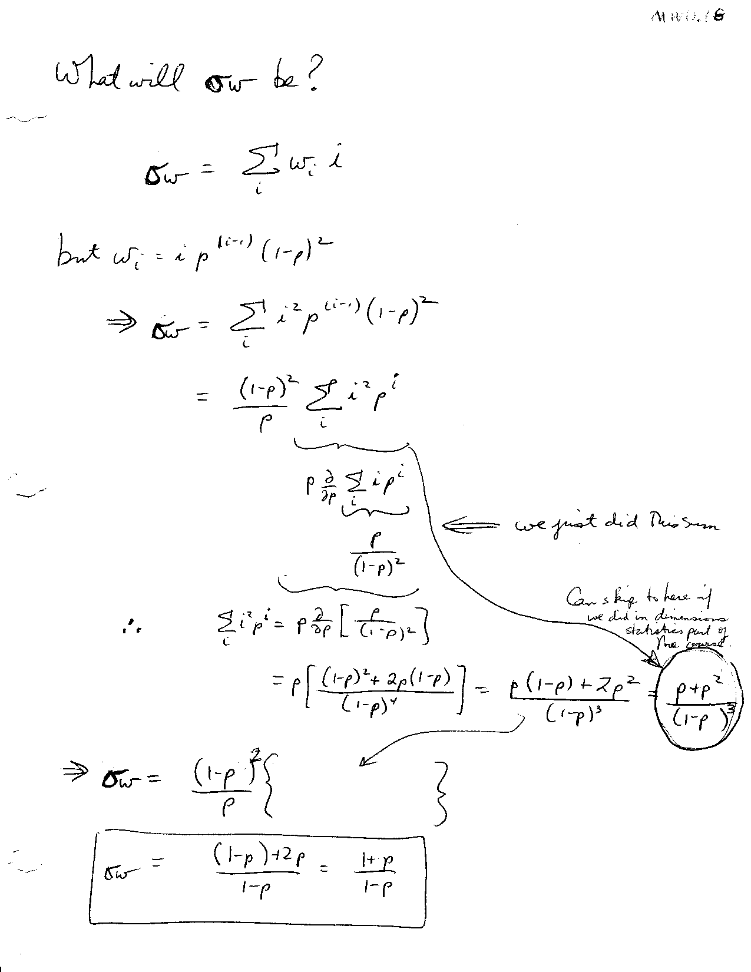

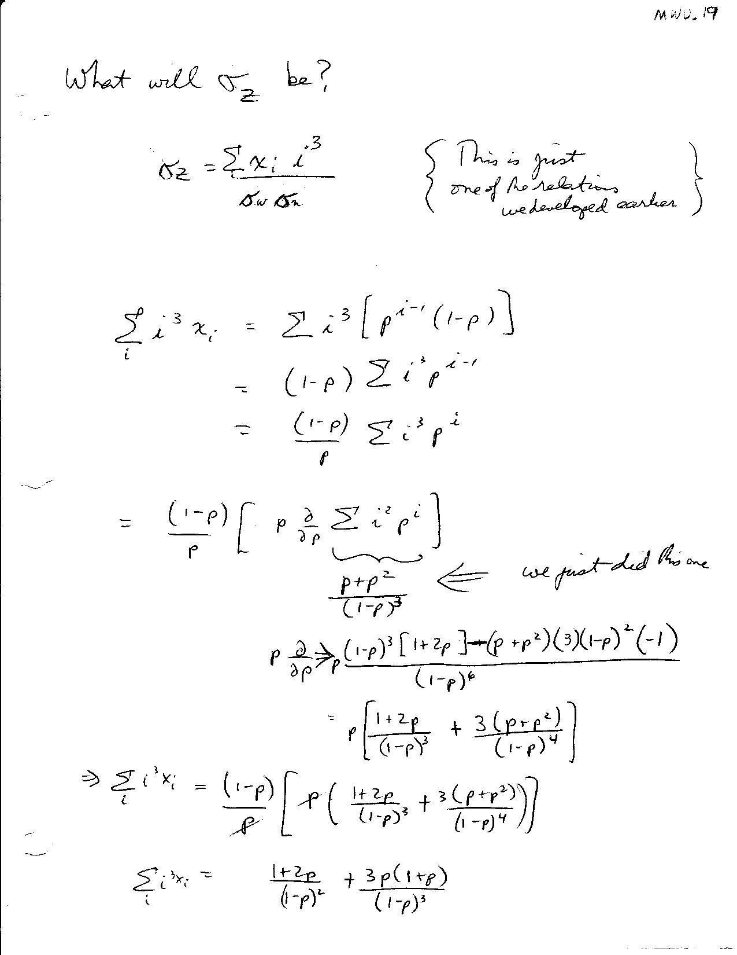

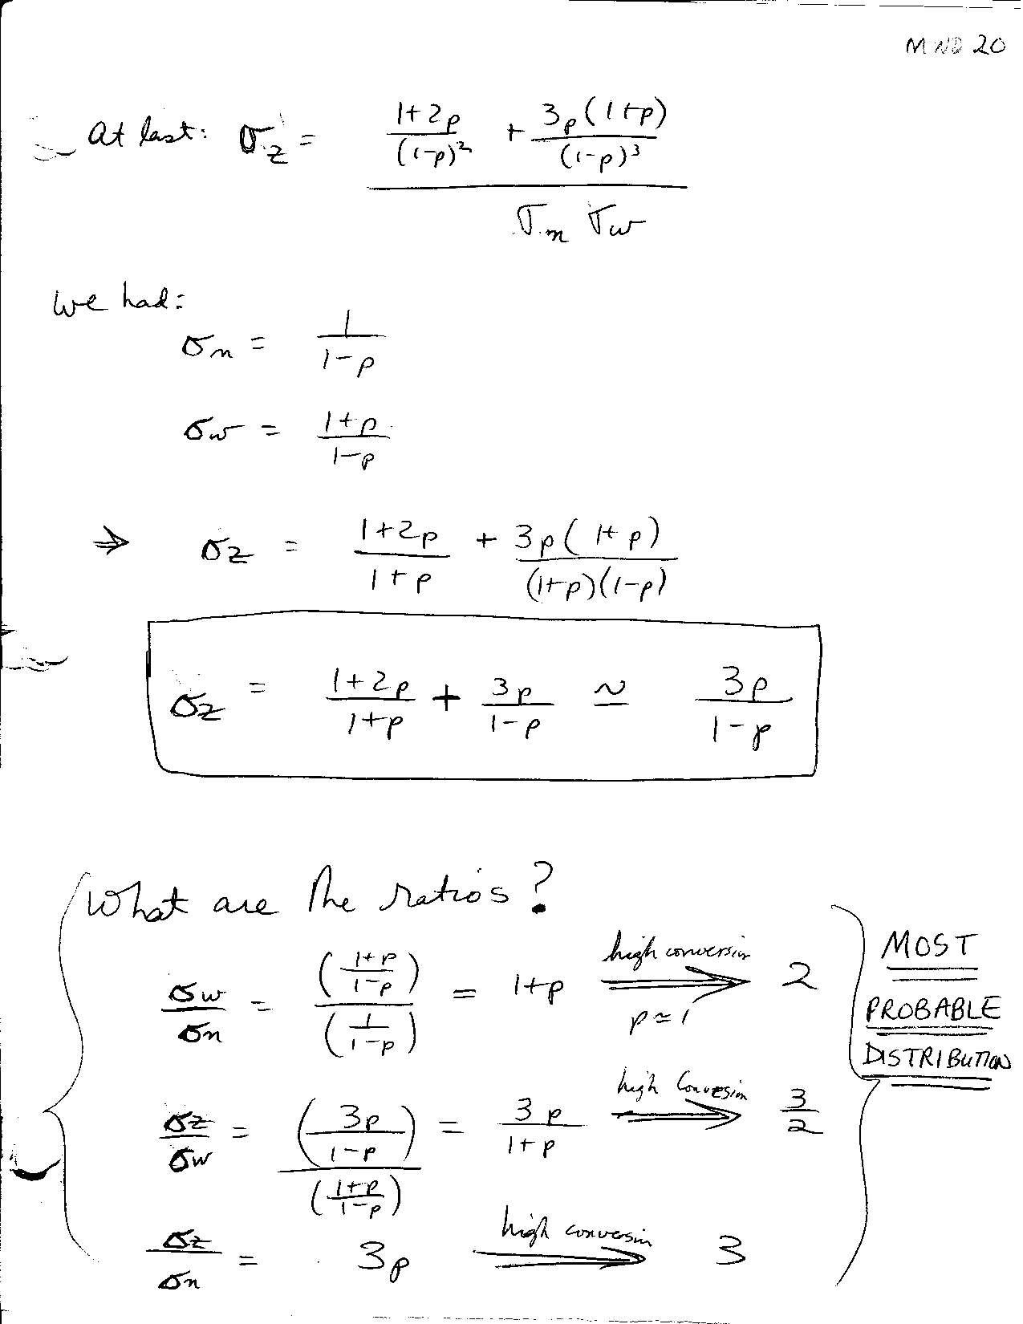

Controlling Molecular Weight Distribution with Star Polymers

It turns out (see Flory 1954) that growing star polycondensates results in narrower distributions. In the example below, we add AB monomer to a 4-functional center.

(AB)n

(AB)n

(AB)n

(AB)n

A

A

A

A

AB +

The statistically-predicted polydispersity ratio for this polymer, in the limit of high conversion, would be *M*w/*M*n = 1.25. For the general *f*-functional polymer, we obtain *M*w/*M*n = 1 + 1/*f*. We may give you the opportunity to prove this in a problem set (Workbook #117).

It is fun to think WHY the polydispersity decreases so much by making a star polymer. A social analogy is entertaining, though hardly rigorous. While a small town in Iowa is different from the next small town (bigger swimming pool, fewer bars, more churches, etc.) the collection of all small towns in a certain county of Iowa is pretty similar to the collection of all small towns in the neighboring county. Small town life in Iowa is small town life in Iowa. In turn, that isn’t very much different from small town life in southern Minnesota or northern Missouri.

You can firm this up by supposing you are making the polymer (4*)-(AB)q(AB)r(AB)s(AB)t where q, r, s and t are the arms and 4* is the four-functional center. It is unlikely that q = r = s = t but it is also unlikely that q,r,s and t are ALL small or ALL big. More probably, if q = small, t will compensate by being large. In other words, the polydispersity on the sum q + r + s + t is smaller than the polydispersity on q, r, s or t taken separately.

# A Physical View of Chain Growth (Addition) Polymerization—The Poisson Distribution

# The physical viewpoint that we have adopted so far works best when one is considering ideal limits. If step-growth/condensation/”anything goes” polymerization is at one end of the spectrum, then *living* addition polymerization is at the other end. In this case, it is imagined that all chains begin growing at once, all of them grow one monomer unit at a time, and all chains keep growing at the same rate until the monomer just runs out. If more monomer were to be added, they would grow some more; they are living, as verified by hunger for more monomer. No side reactions occur to kill the chains. It is perfect addition polymerization.

It is possible to arrange conditions that closely approximate living polymerization ideal. These include ionic polymerizations, ring-openings, etc.

Let there be *M* monomers (not to be confused with mass *M*; sorry, the English alphabet has its limits) and *N* chains (*N* ∝ * *  where * * is the initiator concentration)



σn is easy:

To get distribution, compute the probability (mole fraction) of a chain of *i* monomers.

Each chain is like a box, into which we throw a ball (monomer)

*N* = 2 boxes

2 chains

Pile of *M* balls to place into the *N* boxes.

First let us imagine that all the balls (monomers) are **different**: say they have different colors.

Then let us choose a box (chain) and ask what is the probability it contains the red, green and blue balls **AND** no others. There being *N* boxes, the probability of the red ball in our box is 

The joint probability of red-green-blue is 

For the other *M*-3 balls to be somewhere else, the probability is .

So… *P* = 



Now, suppose we are colorblind: all balls (or monomers) the same.

The red ball could now be any of *M* monomers. This increases probability of **identifiable** states. However, it could go in any of 3 sites: first, second or third. This decreases probability of **identifiable** states. And that is what matters.

Net effect: 

The green ball could be any of *M -* 1 monomers – and can occupy 2 sites in the box: second or third, because the first one is already filled.

Net effect: 

The blue ball can be any of *M*-2 choices & go on only one site

So… *Pcolorblind,3* =  

In general:

*P* = 

(*M-i*)! cancels much of

the numerator

 ⇒ 

But *M* >>> *i* (the biggest chain might have *i* = 105 monomers, while we surely added some pretty significant fraction of Avogadro’s number—maybe 1% of 6 x 1023).

So numerator ≈ *M i*

*Pi*  

Now  because *N* >> 1

So… *Pi*  =  (we again use *M* >>> *i*)

Recall  =  by definition

You should prove --i.e., that the distribution *P*i is normalized.

*Pi* =  **Poisson Distribution**

What about 

We showed this earlier:





In order to proceed, let’s see if we can identify the required sum with some other sum we know. The trick resembles the one we used to get the sums needed for the most probable distribution. Rearrange a bit first:

 =    **Call this Eq. A**

Aha! Definition of 

Consider   

So 

Since we have a sum that we know analytically (just the exponential!) we can use calculus to get the related sums we need, which resemble the exponential in sum form, but involve coefficients of *i* that need to be brought down by differentiation*.*

Let  =  (operating on sum explicitly) = (operating on )

Now consider  =  =  = the desired sum! Differentiating the analytical form of *S*1 (i.e., ) we get:

*S2* =  = 

Now, *S*2 is the product  except for a factor of  (see Eq. A above)

So  = 



or

Weight average DP is ONLY ONE BIGGER than number!



or

|  |  |
| --- | --- |
| ***M*n** | ***M*w*/M*n** |
| 10 | 1.1 |
| 100 | 1.01 |
| 1000 | 1.001 |

If you can arrange a living addition polymerization (oops—living chain growth polymerization for the purists) then it becomes possible to make very uniform polymers, and the bigger they are the more uniform they are. Only problem: even 1.01 is pitiful compared to natural polymers. We do not have a reactor as sophisticated and elegant as the cellular machinery in any living organism. Not only that, but nature can stop the growth better—i.e., the cellular machinery normally arranges that the polymers don’t keep growing just because there’s a soup of monomers hanging around. You might say products of protein synthesis are “dead”. The normal operations of living organisms outclass our living polymerizations by a lot.

Summary of MWD

Fundamental Equations up to Second Moment

 

 

The Chemical Connection Comes by Elaborating *wi*and *xi*. Start with the definition of *wi*.



Now we can summarize according to these three broad categories of polymerization, focusing on the terms circled in blue.

|  |  |  |
| --- | --- | --- |
| AB Polycondensation (most probable/anything goes)  The numerator of the blue-circled term is the number of molecules, which is also equal to the number of not-yet-reacted B groups. The denominator is the number of monomers, equal to the total B groups. Thus, the ratio is (1-p).  *xi = pi-1(1-p)*  *wi = ixi(1-p) = ipi-1(1-p)2* | Star Polycondensation, *f-functional Bf central unit and AB monomers distributed among the f arms.*  This case is like AB polycondensa-tion. The notation uses extent of reaction *p*, but we add a degeneracy factor that is rather like Poisson! You are again placing *i* balls into *f* boxes. This is worked out by placing *f-1* fences and *i* balls.    The *i* vs *i*-1 uncertainty depends on how you define the degree of poly-merization, without central unit or with it, respectively.    Hopefully no typos! | Poisson (living addition with rapid initiation)  Unlike AB polycondensation, the term circled in blue is not carried through to extent of reaction, but that’s just because we do not speak of living addition polymerizations in these terms. We just recognize this term as the number of molecules divided by the number of monomers, or 1/n. |

These equations can be appreciated through the Excel file BigThreeDistributions.xls

1. *Thanks to S. Prager for this analogy.