Polymerization Kinetics –

Can: (a) derive rate expressions (monomer usage, e.g.); (b) derive MWD; (c) predict concentrations as functions of time (batch) or residence time (, continuous flow).

Rate, mechanism, elementary step:

Consider simple initiation of a poly. –

I → 2 R• (rate constant = k₁)

R• + M → M• (k₂)

r₁ = k₁ [I]

r₂ = k₂ [R•] [M]

Elementary = mechanistic = rates of reaction given by stoich.

But tells us nothing about how the concs. change. – need an “overall rate” for this.

Overall rate:

Consider R• -- 2 mols formed in r₁, 1 mol used up in r₂

So r _{R•} = 2 r₁ – r₂

Steady-state approximation: consider two cases

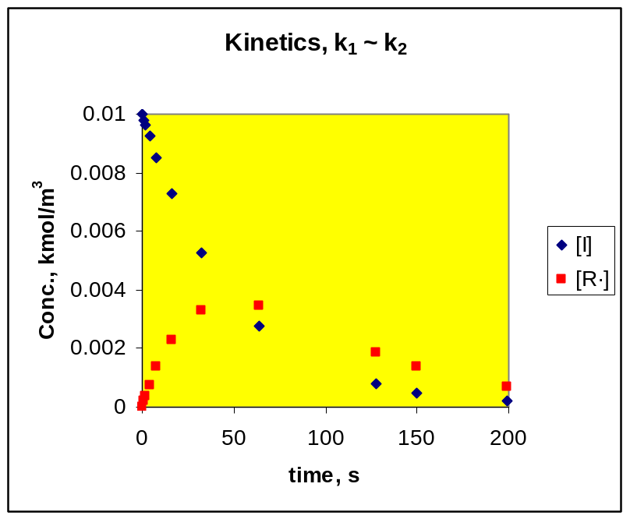
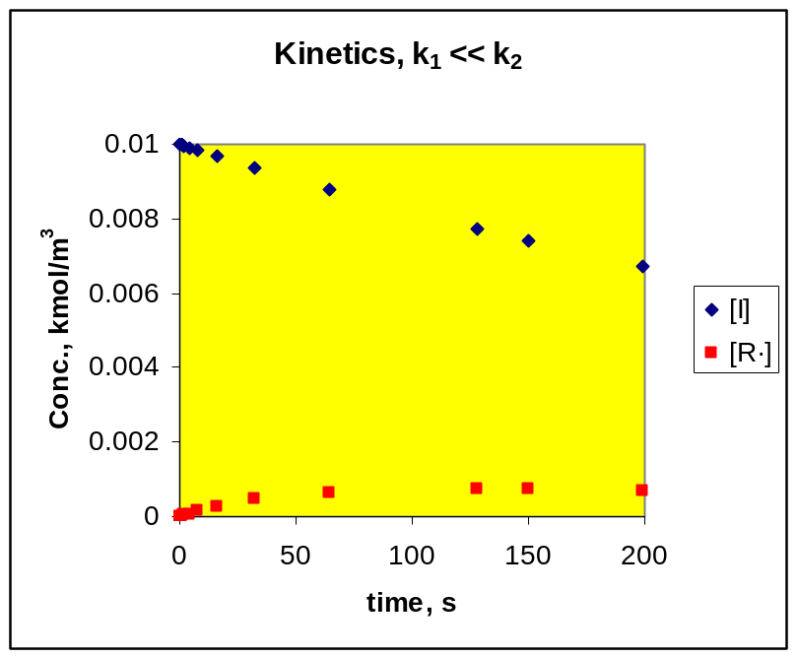
Case 2 more common – intermediate forms slow, decomposes fast.

After short setup time, d[R•]/dt ~ 0 , for long time

So SSA: For all unstable intermediates R• , at t = 0⁺ , d[R•]/dt ~ 0 and:

r _{R•} = 0

Consider typical radical addition poly. –

- hard to find any radicals
- see some polymer immediately

So all intermediates must be in “steady state”, even if the overall process is NOT.

Typical mechanism:

I → 2 R• (rate constant = k₁)

R• + M → M₁• (k₂)

M₁• + M → M₂• (k_{p1}) p for propagation

M₂• + M → M₃• (k_{p2}) etc.

Eventually:

M_{j}• + M_{k}• → P_{k+j} or P_{k} + P_{j} (k_{t}, termination)

X + M_{j}• → X• + P_{j} (k_{tr}, chain transfer)

X• + M → M₁• (k_{x}, chain transfer)

Can also have chain transfer to monomer itself, or to polymer (common, leads to branching), or to initiator. Chain transfer is a more reliable method of MW control in many addition polys.

Kinetics analysis of above –

- R• , M₁• , M_{j}• , X• all unstable

r _{R•} = 2 r₁ – r₂ ~ 0

r_{tr} = k_{tr} [X] Σ [M_{j}•]

r_{X•} = r_{tr} - r_{X} ~ 0

r_{M1•} = +r₂ – r_{P1} - k_{tr} [X] [M₁•] + r_{X} - k_{t} [M₁•] Σ[M_{j}•] ~ 0

r_{M2•} = -r_{P2} + r_{P1} - k_{tr} [X] [M₂•] - k_{t} [M₂•] Σ[M_{j}•] ~ 0

etc.

r_{P} = k_{tr} [X] Σ[M_{j}•] + k_{t} [M₁•] Σ[M_{j}•] + k_{t} [M₂•] Σ[M_{j}•] + k_{t} [M₃•] Σ[M_{j}•] +…

r_{P} = k_{tr} [X] Σ[M_{j}•] + k_{t} (Σ [M_{k}•]) (Σ[M_{j}•])

Now add the “zero” terms r_{X•} , r_{M1•} , r_{M2•} etc.

0 ~ +r₂ – r_{P∞} - k_{t} (Σ [M_{k}•]) (Σ[M_{j}•])

We reject r_{P∞} on physical grounds, and recognize that a “j” and “k” polymer describe the same thing, and so write (using r _{R•} eqn.):

Σ[M_{j}•] = (r₂/k_{t})^{0.5} = (2r₁/k_{t})^{0.5} = [M•]

Since r₁ is usually slow (often so slow that [I] ~ constant), this represents a measurable quantity, an “observable”.

Now can subs. [M•] into r_{p} to get the total poly. rate, in terms of observables. The total rate at which monomer is used up is approx. the sum of the propagation terms (long chain approximation), because almost all monomer used up in propagation. If we then assume:

k_{p1} ~ k_{p2} ~ k_{p3} etc. – just k_{p}

-r_{M} = k_{p} [M] [M_{j}•] = k_{p} (2r₁/k_{t})^{0.5} [M]

Relationship between kinetics, MWD:

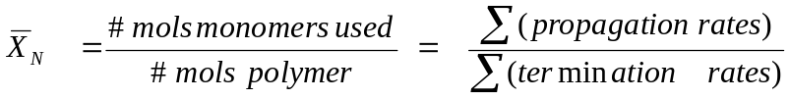

(instantaneous)

Using the above e.g. –

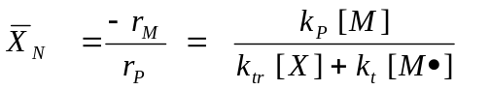

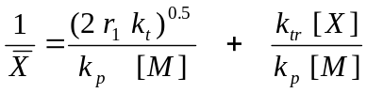

E.G. 1 – Finding a polymer distribution, heuristic method – Radical, term. by combination

Key relationship -

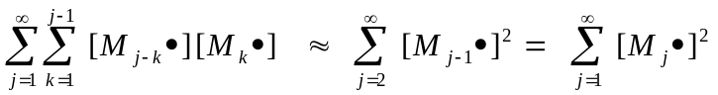

Other keys –

(a) P_{j} mol fraction at time t = (rate to P_{j})/(Σ rates to all P_{k})

(b) Schulz-Flory assumed for the living chains

Kinetics of Step Poly. -

- good e.g., detailed mechanisms - http://www.pslc.ws/mactest/level4.htm
for poly(carbonate) or poly(urethane).

Note that a small molecule need not condense out; if not, either limits MW or requires solvent (why?).

Kinetics and MWD:

http://www.engin.umich.edu/~cre/07chap/html/polymerization.pdf - simplest e.g., stoich. balance

Note that “p” here doesn’t represent a constant prob. wrt time; it is constant wrt all chains.

Therefore question is: do all chains see same “environment” at any time t?
[yes, batch reactor; no, continuous stirred tank reactor]

The form of: ‾X_{N} suggests Schulz-Flory (doesn’t prove it), but it’s proven below. The math is far more complex for case of stoich. imbalance of reactive groups, but this is not common.

Stoich. imbalance – see http://www.engin.umich.edu/~cre/07chap/frames.htm , section I.E

Kinetics of a catalyzed step poly. – see
http://www.engin.umich.edu/~cre/07chap/frames.htm , section I.E

Polymerization Reactor Design

For most polymerizations, the key considerations are:
- Type reactor – batch or continuous (CSTR) ; bulk, solution, suspension, emulsion?
- Temperature – useful range usually narrow
- Initiator, catalyst, chain transfer agent (“modifier”, “endblocker”) concentrations.
- Phase equilibria during the reaction – will polymer precipitate?
- Purity of feed
- Agitation – especially at high viscosity

All have an effect not only on the average MW’s, but also on MWDs.

The basic mass balances:

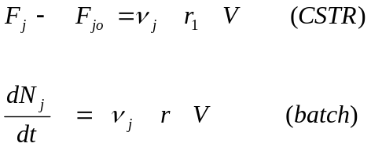

where:

F_{j} = molar flow rate of component j = C_{j} F' = concentration * volumetric flow rate
N_{j} = number mols of component j
_{j} = stoichiometric number of j (e.g., plus for product, minus for reactant)
V = volume of the active phase (NOT the reactor)
Subscript “o” = feed; “1” = exit stream
r = the reaction rate expression

The equations give very different results for most types of polymerizations.
For the CSTR and PFR, the quantity that is analogous to time is the “space time”, V/v₀ = 

General Rule for MWDs of Polymerizations –
Let θ = the average time a chain is growing (including crosslinks). If:

- θ >> t (batch) or τ (CSTR), then a change in t or τ has a great effect on MWD, and so a batch reactor will produce the narrower MWD, because all chains see the same growth time.
- θ << t (batch) or τ (CSTR), then a change in t or τ has less effect on MWD, and a CSTR will produce the narrower MWD, because all chains see the same local composition.

Examples –

- Step (condensation) polymerization (θ is long). Typical MWD (W_{j} = weight of polymer with j units) for a batch (solid line) and a CSTR (dashed line) are shown. The batch typically gives the Flory (most probable) distribution with polydispersity near 2 (p = monomer conversion).

W_{j}

j

- Addition (e.g., free radical, Ziegler-Natta) polymerization (θ short). Now the CSTR gives the narrower MWD, which is often near a Flory (most probable) distribution – see graph below.

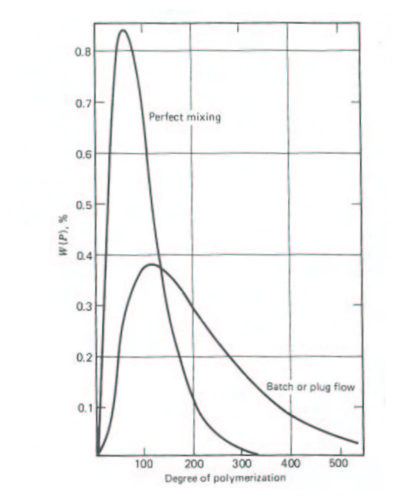

- “Living” Polymerizations – anionic, cationic or metallocene polymerizations with little of no termination – θ can be long
- Addition copolymerizations – not so easy – “local composition” considerations may apply, because may want copolymer at specific A/B ratio.

Mathematics of the Flory Distribution, addition poly.

For no combination:

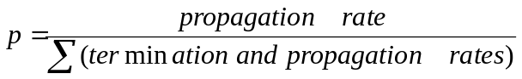

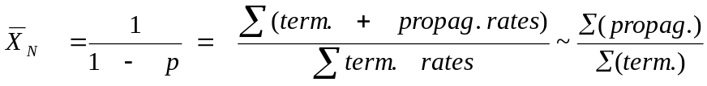

Can also be derived statistically:

y_{j} = mole fraction j-mer = (1-p) p^{j-1}

Note: 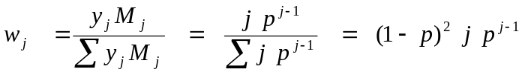

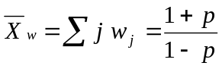

The batch reactor can be modeled as an average of several Flory distributions

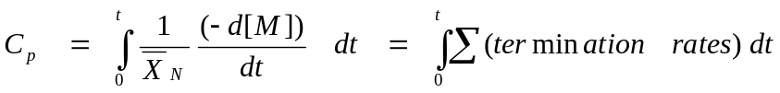

If we consider that the propagation rate >> initiation rate for most polymerizations (“long chain approximation”), it is easy to get this equation from the one preceding it.

(e) Addition polymerization with chain branching.

This is a harder case. For many addition polymerizations, θ is short. But chain branching reactions usually take place over a long time. The following data were collected for vinyl acetate polymerization with chain branching:
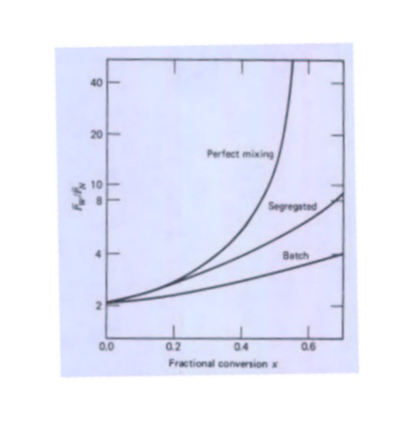

The y-axis is: 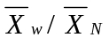 . The X-axis is fraction conversion.
Clearly the batch reactor is superior, which means that the slower branching reaction controls the MWD (θ is long). Fortunately, many CSTRs don’t behave as perfectly mixed in real polymerizations. They exhibit “segregation”, a state of imperfect mixing, especially when the viscosity gets high. We see here that the imperfect mixing actually produces a narrower MWD.
When is a Batch Reactor not a Batch Reactor?

Consider the following case. We have an addition polymerization in suspension, constant T. θ is short. But all of the polymer precipitates as soon as it’s formed. What happens to the concentration of monomer, C_{M}?

C_{M} = N_{M} / V

While N_{M} is certainly decreasing, V (the “active” phase, not the entire suspension) also decreases proportionally, because it’s almost all monomer. Therefore, assuming excess initiator, the rate remains constant also. This means the batch reactor behaves exactly like the CSTR for this case.

Real suspension polymerizations seldom behave exactly like this, because there is usually some polymer solubility in the monomer (and vice-versa). But there is often little enough that C_{M} changes little. This means the batch reactor can give narrow MWD for suspension polymerization (and its cousin, emulsion polymerization), even when θ is short.

Complications in Polymerizations at High Conversion
E.g., addition polymerizations often have observed kinetics that differ from 1st order in monomer.

Ln(1-X)
time
r  [M]²
r  [M]⁰

Above e.g. for Addition Poly. –

[M]^{0-0.5} - Trommsdorff effect – restricted termination – k_{t}  [M]¹⁻²
[M]² – Glass effect – restricted propagation - k_{p}  [M]
Both actually mass transfer effects, but often modeled “kinetically”.

